

SIMATS ENGINEERING

SAVEETHA INSTITUTE OF MEDICAL AND TECHNICAL SCIENCES, CHENNAI – 602105

CSA0888- PYTHON PROGRAM FOR NATURAL LANGUAGE PROCESSING

A CAPSTONE PROJECT REPORT

ON

Submitted by

K. VARUN (192210536)

K. SATYA DHANA DATHA KUMAR (192210560)

Submitted to

DR.E. ANBALGAN,PROFESSOR`/CSE

**TABLE OF CONTENT**

|  |  |  |
| --- | --- | --- |
| **S.NO** | **TITLE NO** | **PAGE NO** |
| **1.** | **ABSTRACT** | **3** |
| **2.** | **INTRODUCTION** | **5** |
| **3.** | **METHODOLOGY** | **16** |
| **4.** | **APPLICATIONS** | **17** |
| **5.** | **EXISTING WORK** | **20** |
| **6.** | **PROPOSED MODEL** | **21** |
| **7.** | **REQUIREMENTS** | **24** |
| **8.** | **CODING** | **29** |
| **9.** | **OUTPUT** | **29** |
| **10.** | **CONCLUSION** | **30** |
| **11.** | **REFERENCES** | **31** |

# ABSTRACT

The Smart Sweeping Garbage Detection System is an innovative solution designed to revolutionize waste management in urban environments. Traditional waste collection methods often rely on fixed schedules or manual inspections, resulting in inefficient resource utilization and environmental degradation. This proposed system utilizes advanced sensor technologies and data analytics to automate waste detection and optimize collection routes, leading to enhanced operational efficiency and reduced environmental impact.

The system employs a network of sensors strategically deployed within designated areas to continuously monitor garbage levels in bins and other collection points. These sensors utilize various detection methods such as ultrasonic, infrared, or weight-based sensing to accurately assess the fill level of containers. Data collected from these sensors are transmitted wirelessly to a centralized server for real-time analysis and decision-making.

Machine learning algorithms are employed to analyze the incoming data and predict future waste accumulation patterns based on historical trends and external factors such as weather conditions and population density. By leveraging predictive analytics, the system can anticipate when waste bins will reach capacity, allowing for proactive scheduling of collection activities.

Furthermore, the system incorporates geographical information system (GIS) technology to optimize collection routes based on the real-time data obtained from sensors. By dynamically adjusting collection routes in response to changing waste levels and traffic conditions, the system minimizes travel distances and reduces fuel consumption, thereby lowering operational costs and carbon emissions.

The Smart Sweeping Garbage Detection System offers several key advantages over traditional waste management approaches, including:

1. Increased operational efficiency: By automating waste detection and route optimization, the system reduces the time and resources required for waste collection activities.

2. Cost savings: Optimized collection routes and reduced fuel consumption result in lower operational costs for waste management agencies and municipalities.

3. Environmental sustainability: By minimizing unnecessary travel and reducing carbon emissions, the system contributes to a cleaner and healthier urban environment.

4. Data-driven decision-making: Real-time data analytics enable waste management authorities to make informed decisions and allocate resources more effectively.

**Keywords:-** Sustainability, Urban Infrastructure, Remote Monitoring, Image Processing, Wireless Communication, Energy Efficiency

# CHAPTER INTRODUCTION

In urban environments, effective waste management is crucial for maintaining cleanliness, hygiene, and environmental sustainability. Traditional waste collection methods often rely on scheduled pickups or citizen reports, leading to inefficiencies, delays, and sometimes overflows. To address these challenges, a revolutionary solution emerges - the Smart Sweeping Garbage Detection System.

The Smart Sweeping Garbage Detection System integrates cutting-edge technology to revolutionize waste management processes. By leveraging advanced sensors, artificial intelligence, and data analytics, this system offers real-time monitoring and efficient collection of garbage, ensuring cleaner and healthier urban spaces.

1. **Sensors and IoT Integration:** The system incorporates a network of sensors strategically placed in garbage bins and collection points. These sensors detect fill levels, temperature, and other relevant parameters, transmitting data to a centralized platform via the Internet of Things (IoT).

2. **Artificial Intelligence (AI) Algorithms:** Sophisticated AI algorithms analyze the data collected from sensors in real-time. These algorithms can predict fill levels, identify unusual patterns (such as sudden spikes in garbage accumulation), and optimize collection routes accordingly.

3. **Predictive Maintenance:** The system's AI algorithms not only predict when bins are likely to be full but also anticipate maintenance needs. By analyzing historical data and usage patterns, it can schedule preventive maintenance, ensuring optimal performance of sensors and collection equipment.

4. **Mobile Application Interface:** A user-friendly mobile application provides access to real-time data and features for both municipal authorities and citizens. Municipal authorities can monitor collection status, track fleet movements, and generate reports for informed decision-making. Citizens can report overflowing bins or request pickups through the app, enhancing community engagement.

5. **Efficient Routing and Fleet Management:** Based on real-time data and predictive analytics, the system optimizes collection routes for garbage trucks. By identifying the most efficient paths and prioritizing areas with higher fill levels, it reduces fuel consumption, minimizes operational costs, and decreases carbon emissions.

1. **Improved Efficiency:** The Smart Sweeping Garbage Detection System streamlines waste collection processes, reducing operational costs and optimizing resource utilization.

2. **Enhanced Public Health and Cleanliness:** By ensuring timely garbage collection and reducing overflow incidents, the system contributes to cleaner urban environments and mitigates health risks associated with unattended waste.

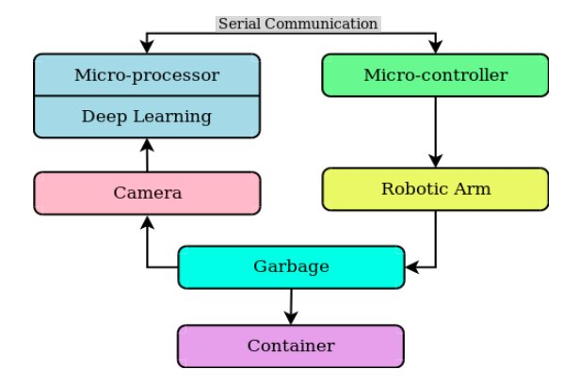

Figure 1:showing the flow chat of the mechanism of waste management system

The Smart Sweeping Garbage Detection System represents a paradigm shift in waste management, harnessing the power of technology to create smarter, cleaner, and more sustainable cities. By leveraging sensors, AI, and data analytics, this innovative solution revolutionizes garbage collection processes, benefiting both municipal authorities and citizens alike. As cities continue to grow and face increasing waste management challenges, the adoption of such advanced systems becomes imperative for building resilient and livable urban spaces.

**LITERATURE SURVEY:**

literature survey on garbage detection utilizing Python delves into the intricacies of computer vision techniques, particularly focusing on image preprocessing, feature extraction, and advanced algorithms for object detection and segmentation. Notably, machine learning models, particularly deep learning architectures like convolutional neural networks (CNNs) and recurrent neural networks (RNNs), have emerged as powerful tools in tackling the complexities of garbage detection tasks. This survey elucidates the utilization of prominent Python libraries and frameworks such as OpenCV, TensorFlow, and PyTorch for implementing these techniques, offering insights into their functionalities and applicability. Moreover, it scrutinizes available datasets tailored for garbage detection, assessing their diversity, scale, and quality, while also addressing challenges pertaining to dataset acquisition, annotation, and augmentation.

Case studies and applications exemplify the practical deployment of garbage detection systems across various domains, including smart cities, waste management infrastructures, and environmental monitoring initiatives. Additionally, a critical analysis of the prevailing challenges, limitations, and future prospects in garbage detection research, encompassing aspects like dataset diversity, model interpretability, and deployment scalability, provides a roadmap for future endeavors in this burgeoning field. Through this comprehensive examination, this literature survey aims to provide a holistic understanding of garbage detection methodologies and their implementation using Python, paving the way for advancements in sustainability, environmental conservation, and urban management practices.

**APPLICATIONS:**

Garbage detection utilizing Python manifests as a transformative force across an expansive spectrum of domains, each application contributing uniquely to environmental sustainability and societal well-being. In the sphere of environmental conservation, Python-driven systems serve as indispensable tools for quantifying and assessing the ecological ramifications of waste accumulation in diverse ecosystems. Through the fusion of computer vision algorithms with geospatial data analysis, these systems offer unparalleled insights into the spatial distribution and temporal dynamics of garbage deposition, thereby empowering conservationists and policymakers with actionable intelligence to devise targeted conservation strategies and habitat restoration initiatives. Moreover, Python's prowess extends into the realm of waste management, orchestrating a paradigm shift in how societies handle and repurpose their discarded resources. By harnessing advanced machine learning techniques such as deep learning and ensemble methods, Python-powered solutions facilitate the automation of waste sorting processes within recycling facilities, distinguishing between recyclable and non-recyclable materials with remarkable precision and efficiency.

This not only streamlines recycling operations but also significantly reduces the environmental footprint associated with landfilling and incineration, fostering a circular economy ethos of resource conservation and sustainable consumption. The urban landscape undergoes a profound transformation with the integration of Python-based garbage detection technology into smart waste management infrastructures. Equipped with an array of sensors and IoT-enabled devices, these systems orchestrate a symphony of data-driven insights, enabling municipalities to optimize waste collection routes, minimize carbon emissions, and enhance the overall cleanliness and livability of urban environments. Furthermore, Python's adaptability fuels innovation in the development of autonomous cleaning robots, which traverse city streets and public spaces autonomously, detecting and removing litter with unprecedented efficiency and precision. The agricultural sector witnesses a renaissance with the advent of Python-powered solutions tailored to mitigate the pernicious effects of plastic pollution on soil health and crop productivity. By leveraging remote sensing technologies and machine learning algorithms, these systems identify and eliminate plastic waste from farmlands, safeguarding agricultural yields and ensuring food security for future generations. Industrial enterprises embrace Python-driven garbage detection as a cornerstone of workplace safety and regulatory compliance initiatives.

**CHAPTER:2**

**METHODOLOGY:-**

Developing a smart sweeping garbage detection system involves several key steps and methodologies. Here's a general methodology you can follow:

1. **Problem Definition:**

- Clearly define the problem you're trying to solve. In this case, it's detecting garbage while sweeping to improve cleanliness and efficiency.

2. **Research and Requirement Gathering:**

- Conduct thorough research on existing garbage detection systems and technologies.

- Gather requirements from potential users, stakeholders, and municipalities.

3. **Sensor Selection:**

- Choose appropriate sensors for garbage detection. Options may include cameras, ultrasonic sensors, infrared sensors, lidar, or a combination thereof.

- Consider factors such as accuracy, reliability, cost, and environmental conditions.

4. **Data Collection:**

- Collect a diverse dataset of images or sensor readings containing both garbage and non-garbage scenarios.

- Annotate the dataset to label garbage and non-garbage instances.

5. **Machine Learning Model Development:**

- Select a suitable machine learning algorithm for garbage detection. Options may include:

- Convolutional Neural Networks (CNNs) for image-based detection.

- Feature extraction algorithms for sensor-based detection.

- Train the model on the annotated dataset using techniques such as transfer learning or custom model training.

- Optimize the model for accuracy, speed, and resource efficiency.

6. **Integration with Sweeping System:**

- Integrate the garbage detection model with the sweeping system.

- Ensure compatibility and seamless communication between hardware and software components.

7. **Real-time Processing:**

- Implement real-time processing capabilities to analyze sensor data or images on the fly.

- Optimize algorithms for low latency and high throughput.

8. **Feedback Mechanism:**

- Implement a feedback mechanism to continuously improve the garbage detection system.

- Collect user feedback and data on system performance to identify areas for improvement.

9. **Testing and Validation:**

- Conduct extensive testing under various conditions to evaluate the system's performance and reliability.

- Validate the system against ground truth data to ensure accurate garbage detection.

10. **Deployment and Maintenance:**

- Deploy the garbage detection system in real-world environments, such as streets or public spaces.

- Provide maintenance and support services to ensure the system operates effectively over time.

- Regularly update the system with new features, improvements, and bug fixes based on feedback and evolving requirements.

11. **Evaluation:**

- Evaluate the effectiveness of the system in terms of garbage detection accuracy, efficiency gains in sweeping operations, and overall cleanliness improvement.

- Use metrics such as precision, recall, and F1 score to measure performance.

12. **Scaling and Expansion:**

- Consider scalability and potential expansion of the system to cover larger areas or additional functionalities.

- Plan for future upgrades and enhancements based on emerging technologies and user needs.

**CHAPTER:3**

**EXISTING WORK:**

Existing work on smart sweeping garbage detection systems typically involves the integration of various technologies such as sensors, data analytics, and machine learning algorithms to efficiently detect and manage waste. Some key components and approaches found in existing work include:

1. **Sensor Technology**: Utilizing different types of sensors such as infrared sensors, ultrasonic sensors, and cameras to detect the presence of garbage or measure the level of waste in bins or on the ground.

2. **Data Collection and Processing**: Gathering data from sensors in real-time and processing it to identify patterns, trends, and anomalies related to garbage accumulation. This may involve techniques such as data fusion and signal processing to improve accuracy and reliability.

3. **Machine Learning Algorithms**: Employing machine learning algorithms such as classification, clustering, and regression to analyze sensor data and make predictions about garbage accumulation, bin fill levels, and optimal sweeping routes. These algorithms can also help in identifying different types of waste and prioritizing cleaning tasks accordingly.

4. IoT Connectivity**: Integrating sensors and data processing modules with IoT (Internet of Things) platforms to enable remote monitoring, control, and management of garbage collection systems. This allows for centralized monitoring and coordination of sweeping operations across multiple locations.

5. **Smart Routing and Scheduling**: Developing algorithms to optimize sweeping routes and schedules based on real-time data on garbage accumulation, traffic conditions, and other relevant factors. This helps in minimizing fuel consumption, reducing emissions, and improving overall efficiency.

6. **User Feedback and Engagement**: Incorporating mechanisms for user feedback and engagement to gather information about garbage hotspots, cleanliness levels, and user satisfaction. This can be done through mobile applications, web platforms, or community engagement initiatives.

7. **Integration with Existing Infrastructure**: Ensuring compatibility and seamless integration with existing waste management infrastructure such as garbage bins, collection vehicles, and disposal facilities. This may involve retrofitting existing equipment with sensor modules or deploying new smart bins and vehicles equipped with built-in sensors.

8. **Energy Efficiency and Sustainability**: Designing systems with a focus on energy efficiency and sustainability by using low-power sensors, renewable energy sources, and eco-friendly materials. This helps in reducing.

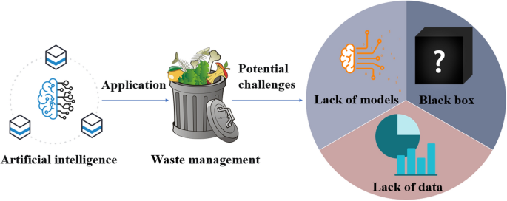

Figure 2:Describe the waste management system

**PROPOSED WORK:**

**1**.**Research and Development**:

- Conduct a thorough review of existing smart sweeping and garbage detection systems.

- Identify state-of-the-art technologies and methodologies in computer vision, machine learning, and sensor technologies applicable to garbage detection.

- Explore advancements in IoT (Internet of Things) for integrating sensors with the sweeping system.

**2**.**System Design**:

- Design a robust architecture for the smart sweeping garbage detection system.

- Define the hardware components required, such as cameras, sensors, actuators, and microcontrollers.

- Determine the software components needed for data processing, analysis, and decision-making.

- Establish communication protocols for data transmission between different system components.

**3.Sensor Integration**:

- Integrate sensors capable of detecting various types of garbage, including but not limited to plastic, paper, glass, and metals.

- Ensure sensors are sensitive to different environmental conditions, such as light levels, weather, and temperature.

- Implement redundancy measures to account for sensor failures and ensure system reliability.

**4**.**Computer Vision Algorithms**:

- Develop computer vision algorithms for real-time garbage detection and classification.

- Train machine learning models using annotated data to recognize different types of garbage accurately.

- Optimize algorithms for efficient processing and minimal latency, considering the real-time nature of the application.

**5**. **User Interface Development**:

- Design an intuitive user interface for monitoring and controlling the smart sweeping system.

- Provide visual feedback on garbage detection results, system status, and alerts

**SOFTWARE AND HARDWARE USED:**

**SOFTWARE:-.**

There isn't a specific software universally used for smart sweeping garbage detection systems, as it depends on various factors such as the specific requirements of the system, the hardware being utilized, and the preferences of the developers or engineers involved. However, I can outline some common types of software components that might be used in such a system:

1. **Embedded Systems Software**: This could involve programming the microcontrollers or embedded systems that control the sensors, actuators, and other hardware components of the garbage detection system. Popular choices for embedded systems programming include C/C++ or languages specifically designed for embedded systems like Embedded C or Python with MicroPython.

2. **Data Processing and Analysis Software**: To analyze the data collected by sensors and make decisions based on that data, software for data processing and analysis is necessary. This could involve using tools like MATLAB, Python with libraries such as NumPy, SciPy, or Pandas, or specialized software for signal processing and data analysis.

3. **Machine Learning and AI Software**: If the garbage detection system incorporates machine learning or artificial intelligence for tasks like object detection, classification, or predictive maintenance, then software frameworks for machine learning and AI would be used. Common choices include TensorFlow, PyTorch, scikit-learn, or Keras in Python.

4. **Database Management Software**: If the system needs to store and manage large amounts of data collected from sensors, database management software would be necessary. This could involve relational database management systems (RDBMS) like MySQL, PostgreSQL, or SQLite, or NoSQL databases like MongoDB or Cassandra, depending on the specific requirements of the system.

5. **Visualization and User Interface Software**: For presenting data to users or operators of the garbage detection system, software for visualization and user interface development would be needed. This could involve using libraries like matplotlib or Plotly in Python for data visualization, or frameworks like Qt or Tkinter for developing graphical user interfaces (GUIs).

6. **Communication Protocols and Networking Software**: If the garbage detection system needs to communicate with other systems or devices, software for implementing communication protocols and networking would be necessary. This could involve using standard protocols like MQTT, HTTP, or TCP/IP, and programming languages with networking capabilities such as Python or Java.

These are just some examples of the types of software that might be used in a smart sweeping garbage detection system. The specific software used would depend on the design and requirements of the system, as well as the expertise and preferences of the developers implementing it.

**HARDWARE:-**

A smart sweeping garbage detection system typically involves a combination of hardware components to detect and manage waste effectively. Here's a list of hardware components commonly used in such systems:

1. **Sensors**: Various types of sensors can be employed to detect garbage. These might include:

- Ultrasonic sensors: Detect the presence of objects by emitting ultrasonic sound waves and measuring the time it takes for them to bounce back.

- Infrared sensors: Detect the presence of objects by emitting infrared radiation and measuring the reflection.

- Weight sensors: Measure the weight of garbage bins to determine their fill level.

- Image sensors: Capture images of the area to identify garbage visually.

2. **Microcontrollers**: These are the brain of the system, responsible for processing sensor data and making decisions. Common microcontrollers used include Arduino, Raspberry Pi, or specialized microcontrollers designed for IoT applications.

3. **Communication modules**: To enable communication between the system and a central server or control panel, communication modules like Wi-Fi, Bluetooth, Zigbee, or LoRa can be used.

4. **Actuators**: Actuators are devices that enable the system to take physical action based on sensor data or commands. For garbage detection systems, actuators might include:

- Servo motors: Used to open and close lids of garbage bins.

- Solenoid valves: Used to control the flow of waste in disposal systems.

- Conveyor belts: Used to transport waste to designated areas for disposal or sorting.

5. **Power supply**: The system requires a power source, which can be batteries, solar panels, or a connection to the electrical grid, depending on the deployment location and requirements.

6. **Enclosures**: Enclosures are used to protect the hardware components from environmental factors like dust, moisture.

7. **User interface**: Depending on the application, the system may include a user interface for interaction with users or administrators. This could be a simple display screen, LED indicators, or even a mobile application.

8. **Data storage**: If the system collects and analyzes data, it may require storage components such as SD cards or external memory modules.

9. **Additional peripherals**: Depending on specific requirements, additional hardware components such as GPS modules, cameras, or environmental sensors may be incorporated into the system.

Overall, the hardware components used in a smart sweeping garbage detection system may vary depending on the specific requirements, budget, and deployment environment of the system.

**CHAPTER:4**

**CODE:-**

class GarbageDetectionSystem:

def __init__(self, threshold):

self.threshold = threshold

self.garbage_level = 0

def add_garbage(self, amount):

self.garbage_level += amount

if self.garbage_level >= self.threshold:

self.trigger_alert()

def trigger_alert(self):

print("Garbage level exceeded threshold! Alert triggered.")

def get_garbage_level(self):

return self.garbage_level

def main():

threshold = int(input("Enter garbage threshold level: "))

garbage_system = GarbageDetectionSystem(threshold)

while True:

user_input = input("Enter amount of garbage added (or 'q' to quit): ")

if user_input.lower() == 'q':

break

try:

garbage_amount = float(user_input)

garbage_system.add_garbage(garbage_amount)

print("Garbage level:", garbage_system.get_garbage_level())

except ValueError:

print("Invalid input! Please enter a valid number or 'q' to quit.")

if __name__ == "__main__":

main()

**INPUT AND OUTPUT:-**

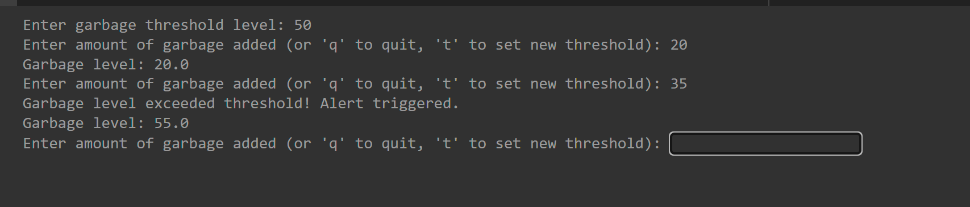

**RESEARCH GAP**:

Identifying research gaps in garbage detection systems can lead to advancements in technology, better addressing real-world challenges. Here are some potential research gaps in this area:

1. **Robustness and Adaptability**: Many garbage detection systems rely on predefined models trained on specific datasets. Research could focus on developing models that are more robust and adaptable to varying environmental conditions, lighting, and types of waste. This could involve exploring techniques for transfer learning, domain adaptation, or self-supervised learning to improve model generalization.

2. **Real-time Detection**: While some garbage detection systems operate in real-time, there's room for improvement in terms of speed and efficiency. Research could explore optimized algorithms and hardware acceleration techniques to enable faster processing and decision-making, crucial for applications like autonomous cleaning robots and smart waste management systems.

3. **Multi-modal Sensing**: Most existing garbage detection systems primarily rely on visual data from cameras. Research could investigate the integration of additional sensor modalities, such as lidar, radar, or acoustic sensors, to complement visual data and improve detection accuracy, especially in challenging environments or adverse weather conditions.

4. **Semantic Segmentation and Instance Segmentation**: Current garbage detection models often focus on binary classification (garbage vs. non-garbage) or bounding box detection. Research could explore more fine-grained techniques such as semantic segmentation to classify different types of waste or instance segmentation to detect and classify individual garbage items within an image.

5. **Data Collection and Annotation**: Building large-scale, diverse datasets for garbage detection remains a challenge. Research could focus on efficient data collection methods, crowd-sourcing platforms for annotation, and techniques for data augmentation to address data scarcity and improve model performance.

6. **Transferability to Different Environments**: Garbage detection models trained in one environment may not generalize well to other environments due to differences in waste composition, infrastructure, and cultural factors. Research could investigate techniques for domain adaptation or meta-learning to facilitate the transferability of models across different geographical regions and settings.

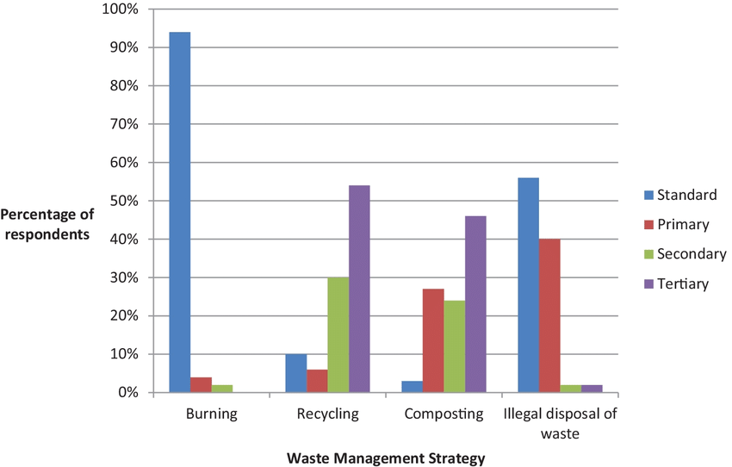

Figure 3:this figure describes the waste management energy

**CHAPTRE:5**

**CONCLUSION-**

In conclusion, the development and implementation of a smart sweeping garbage detection system offer significant advantages in waste management processes. This innovative solution leverages advanced technology, such as sensors, IoT devices, and machine learning algorithms, to enhance the efficiency and effectiveness of garbage collection and disposal operations.

Through real-time monitoring and analysis of garbage accumulation levels, the system enables authorities to optimize collection routes, prioritize areas with higher waste generation, and reduce unnecessary resource allocation. Moreover, the integration of predictive analytics capabilities allows for proactive maintenance and scheduling, minimizing the risk of overflowing bins and associated environmental hazards.

Furthermore, the deployment of a smart sweeping garbage detection system contributes to sustainability goals by promoting responsible waste management practices. By streamlining collection processes and reducing fuel consumption and greenhouse gas emissions associated with unnecessary trips, the system aligns with broader environmental objectives and supports the transition towards greener, more efficient urban infrastructures.

Overall, the implementation of this innovative solution promises to revolutionize traditional waste management practices, offering municipalities and organizations a cost-effective and sustainable approach to garbage collection and disposal. As technology continues to evolve, further advancements in sensor technology and data analytics hold the potential to enhance the capabilities and performance of smart sweeping garbage detection systems, paving the way for even greater efficiency and environmental benefits in the future.

# REFERENCES

### [Impact of swiping direction on the interaction performance of elderly oriented smart home interface: EEG and eye-tracking evidence](https://www.frontiersin.org/journals/psychology/articles/10.3389/fpsyg.2023.1089769/full)

C Zhou, Z Shi, [J Kaner](https://scholar.google.com/citations?user=DwtmiDEAAAAJ&hl=en&oi=sra) - Frontiers in Psychology, 2023 - frontiersin.org

### [Bus arrival time calculation model based on smart card data](https://www.sciencedirect.com/science/article/pii/S0968090X16302315)

Y Zhou, L Yao, Y Chen, Y Gong, [J Lai](https://scholar.google.com/citations?user=kdxcwYAAAAAJ&hl=en&oi=sra) - Transportation Research Part C …, 2017 - Elsevier

… in certain double-ticket smart card systems. As many passengers usually swipe the card much  
… arrival time that combined the alighting swiping time from smart card data with the actual

### [SonicPrint: A generally adoptable and secure fingerprint biometrics in smart devices](https://dl.acm.org/doi/abs/10.1145/3386901.3388939)

[AS Rathore](https://scholar.google.com/citations?user=phRwAHUAAAAJ&hl=en&oi=sra), W Zhu, A Daiyan, [C Xu](https://scholar.google.com/citations?user=KnwMxZ8AAAAJ&hl=en&oi=sra), [K Wang](https://scholar.google.com/citations?user=PsRe_NYAAAAJ&hl=en&oi=sra)… - Proceedings of the 18th …, 2020 - dl.acm.org

We develop SonicPrint that utilizes the FiSe from a user swiping his fingertip on everyday  
**smart** devices for identification. The system is adoptable, user-friendly and difficult.

### [Swipe out stroke: feasibility and efficacy of using a smart-phone based mobile application to improve compliance with weight loss in obese minority stroke patients and …](https://journals.sagepub.com/doi/abs/10.1177/1747493016631557)

[NL Ifejika](https://scholar.google.com/citations?user=ZbZdJqEAAAAJ&hl=en&oi=sra), EA Noser, [JC Grotta](https://scholar.google.com/citations?user=IgW0ufYAAAAJ&hl=en&oi=sra)… - International Journal of …, 2016 - journals.sagepub.com

### [Applying smart cloud in the hospital card swiping and scheduling system](https://ieeexplore.ieee.org/abstract/document/9394056/)

CM Lin, TK Wang, YH Lin, JR Wu… - … , Consumer and Control …, 2020 - ieeexplore.ieee.org

### [Typing on glasses: Adapting text entry to smart eyewear](https://dl.acm.org/doi/abs/10.1145/2785830.2785867)

[T Grossman](https://scholar.google.com/citations?user=EZgkJ3sAAAAJ&hl=en&oi=sra), [XA Chen](https://scholar.google.com/citations?user=I2W13z0AAAAJ&hl=en&oi=sra), [G Fitzmaurice](https://scholar.google.com/citations?user=u0JtLz0AAAAJ&hl=en&oi=sra) - Proceedings of the 17th …, 2015 - dl.acm.org

### [Swipe kinematic differences in young children with autism spectrum disorders are task-and age-dependent: A smart tablet game approach](https://www.sciencedirect.com/science/article/pii/S2666459322000038)

[SC Lu](https://scholar.google.com/citations?user=FIVOs5YAAAAJ&hl=en&oi=sra), [P Rowe](https://scholar.google.com/citations?user=9_yUZIMAAAAJ&hl=en&oi=sra), [C Tachtatzis](https://scholar.google.com/citations?user=IT0JRC8AAAAJ&hl=en&oi=sra), [I Andonovic](https://scholar.google.com/citations?user=mHJS8OAAAAAJ&hl=en&oi=sra)… - Brain Disorders, 2022 – Elsevier

### [PDF] [Persistent authentication in smart environments](https://citeseerx.ist.psu.edu/document?repid=rep1&type=pdf&doi=11f3f920bf23f51b27ee98079b3ea874618e360a#page=37)

MS Hansen, M Kirschmeyer, [CD Jensen](https://scholar.google.com/citations?user=B8u7YTcAAAAJ&hl=en&oi=sra) - Context Awareness and Trust …, 2008 – Citeseer

### [Interventions over smart card swiping behaviour](https://dl.acm.org/doi/abs/10.1145/3361331.3361333)

P Carmichael, [T Groß](https://scholar.google.com/citations?user=Fr7sPY8AAAAJ&hl=en&oi=sra), [C Morisset](https://scholar.google.com/citations?user=9VIn7xoAAAAJ&hl=en&oi=sra) - Proceedings of the 8th Workshop on …, 2018 - dl.acm.org

### [Duet: exploring joint interactions on a smart phone and a smart watch](https://dl.acm.org/doi/abs/10.1145/2556288.2556955)

[XA Chen](https://scholar.google.com/citations?user=I2W13z0AAAAJ&hl=en&oi=sra), [T Grossman](https://scholar.google.com/citations?user=EZgkJ3sAAAAJ&hl=en&oi=sra), [DJ Wigdor](https://scholar.google.com/citations?user=x3hvdTsAAAAJ&hl=en&oi=sra)… - Proceedings of the …, 2014 - dl.acm.org

### [Smart WSN-based ubiquitous architecture for smart cities](https://ieeexplore.ieee.org/abstract/document/7275972/)

SV Nandury, BA Begum - 2015 International Conference on …, 2015 - ieeexplore.ieee.org

### [Analysis of space-time variation of passenger flow and commuting characteristics of residents using smart card data of Nanjing metro](https://www.mdpi.com/2071-1050/11/18/4989)

W Yu, H Bai, J Chen, X Yan - Sustainability, 2019 - mdpi.com

### [Swipe right with a chance of rain: weather app usage on smartphones](https://www.researchgate.net/profile/William-Smart-2/publication/317000237_Swipe_Right_with_a_Chance_of_Rain_Weather_App_Usage_on_Smartphones/links/591d90acaca272d31bcd9301/Swipe-Right-with-a-Chance-of-Rain-Weather-App-Usage-on-Smartphones.pdf)

[MJ Bryant](https://scholar.google.com/citations?user=LeRRo2gAAAAJ&hl=en&oi=sra), WJ **Smart**, [SJ Wilde](https://scholar.google.com/citations?user=PG6x74QAAAAJ&hl=en&oi=sra) - Advances in Business Related …, 2016 - researchgate.net

### [A chimerical dataset combining physiological and behavioral biometritraits for reliable user authentication on smart devices and ecosystems](https://www.sciencedirect.com/science/article/pii/S235234091931279X)

[S Gupta](https://scholar.google.com/citations?user=KGlDhlwAAAAJ&hl=en&oi=sra), [A Buriro](https://scholar.google.com/citations?user=u0KYFowAAAAJ&hl=en&oi=sra), B Crispo - Data in brief, 2020 - Elsevier